**Journal:** Ecosphere

**Manuscript** **type**: Article

**Title:** Soil climate underpins year effects driving divergent outcomes in semi-arid cropland to grassland restoration

**Authors**: Adam L. Mahood*, David M. Barnard, Jacob A. Macdonald, Timothy R. Green, Robert H. Erskine

*corresponding author: [admahood@gmail.com](mailto:admahood@gmail.com)

**Affiliations**: Water Resources, USDA-ARS

**ORCIDs**: ALM: 0000-0003-3791-9654

DMB: 0000-0003-1877-3151

JAM: 0009-0009-3093-0667

TRG: 0000-0002-1441-8008

**Open Research Statement:** All data and code are in a public repository, https://www.github.com/admahood/drake-crp, and will be archived at zenodo.org upon acceptance.

**Keywords**: Bromus tectorum, Cheatgrass, Conservation Reserve Program, Ecosystem Restoration, Interannual Climate Variability, Plant Functional Groups, Pascopyrum smithii, Western Wheatgrass, Year Effects

# Abstract

Converting croplands to grasslands can restore ecosystem functions and services, but there is uncertainty about why some restoration treatments succeed and others do not. One likely explanation for variation in restoration outcomes is that interannual variation in the drivers of community assembly, or “year effects”, are often overlooked in restoration planning. Existing restoration strategies tailor species compositions of seed mixes according to long-term climate means and hardiness zones. However, individual years typically deviate from average climate norms such that restoration activities may be better informed by recent conditions than by climate averages. We monitored a 109 ha field in northeastern Colorado that was converted from a winter wheat-fallow rotation to native perennial grassland via seeding. The same seed mix was used to seed 6 of 12 120 m strips in 2013 (drier) and 6 in 2014 (wetter). In the strips seeded in 2013, only one native grass and one shrub species from the seed mix established widely, whereas in 2014 all native grasses established. Higher soil moisture preceding seed application was positively associated with perennial grasses, while rhizomatous grasses, shrubs and introduced annuals were associated with other variables. After seeding, high summer soil moisture was positively associated with a rhizomatous C3 grass, while the planted C4 bunchgrasses were negatively associated with high summer soil moisture and positively associated with high fall soil temperatures. We found evidence of facilitatory interactions between grasses and forbs, and antagonistic interactions between native perennial grasses and non-native annuals. Our results suggest that the conditions immediately before and after planting govern community assembly and leave a lasting legacy and should be considered in planning treatments. We suggest composing seed mixes that are tailored to commonly encountered extremes of temperature and moisture availability. Land managers can also use split-seeding or repeated seeding approaches, within or between years as bet-hedging strategies. The development of more flexible funding mechanisms could allow for regional go/no-go climate thresholds to avoid wasting resources.

# Introduction

Restoration efforts to convert croplands back to native grasslands yield novel ecosystems whose community assemblage is poorly understood, representing one of the more important contemporary ecological questions [(Armstrong *et al.*, 2023; Bell *et al.*, 2023)](https://www.zotero.org/google-docs/?5CyQCT). Reestablishing native perennial plant cover in post-agricultural landscapes is an important way to restore these systems to carbon sinks and enhance soil stabilization, biodiversity and other ecosystem functions and services. However, in order to realize these benefits, native perennial plants need to be successfully established, which can prove challenging given the impacts of interannual climate variability and year effects on key drivers of plant establishment such as soil moisture and temperature. The complexity of predicting reestablishment outcomes is even more challenging in areas managed for long periods as intensive agriculture, because the native seed bank is often depleted, soil fertility has declined, non-native plants are abundant, and ecohydrological function has been altered [(Turnbull *et al.*, 2012; Shackelford *et al.*, 2021)](https://www.zotero.org/google-docs/?URJcJy). Furthermore, restoration practitioners typically rely on mean annual climate conditions when selecting species for seed mixes. But substantial variability in the timing and magnitude of precipitation both inter- and intra-annually can lead to a soil moisture abundance or deficits during key seed germination and establishment phases that can drive long-term restoration outcomes (O’Connor 2018). Therefore it is essential to consider potential variability in climate as much as mean conditions when planning restoration projects, especially in drylands.

Many government subsidies exist to incentivize land owners to convert cropland back to native vegetation to improve biodiversity and ecosystem services. In the United States, the Conservation Reserve Program (CRP) has been paying farmers to convert cropland to perennial vegetation since 1985. As of 2020 there were 8.9 million hectares enrolled, with the Western Great Plains region having the greatest enrollment [(USDA, 2023)](https://www.zotero.org/google-docs/?KLrjcC). Landowners follow state- or regional-level guidelines for seed application [(Taliga, 2011)](https://www.zotero.org/google-docs/?ujcPC4), often with restored plant communities remaining even after CRP payments have ceased [(Vandever *et al.*, 2023)](https://www.zotero.org/google-docs/?7kDuEq). Successful CRP treatments have been shown to increase soil microbial function [(Li *et al.*, 2018)](https://www.zotero.org/google-docs/?2ilmkl) and biomass [(Bach, Baer and Six, 2012)](https://www.zotero.org/google-docs/?eNhdlE), preserve freshwater ecosystem services [(Huang *et al.*, 2019)](https://www.zotero.org/google-docs/?ZNHkMV), improve pollinator health [(Ricigliano *et al.*, 2019)](https://www.zotero.org/google-docs/?qOH6wd), and increase soil carbon mineralization [(Bach, Baer and Six, 2012)](https://www.zotero.org/google-docs/?6l3eUb). Conversion from croplands to perennial grassland can also decrease soil erosion, increase soil organic carbon [(Ye *et al.*, 2023)](https://www.zotero.org/google-docs/?7ywnGA), and moderate soil temperatures [(Huang *et al.*, 2023)](https://www.zotero.org/google-docs/?YgIcQ5). However, despite the outcomes of successful seedings being well documented, more investigation is needed on the year effects and landscape and climate factors that dictate seeding success and the associated improvements in ecosystem functioning.

Regional guidance for species selection, seeding rates, and timing of treatment currently follows seeding zones based on ecological site type and annual climate means [(Taliga, 2011)](https://www.zotero.org/google-docs/?w9M3Sr). However, as the climate continues to become warmer, drier, and more variable [(Yuan *et al.*, 2023)](https://www.zotero.org/google-docs/?iHwwD9), further driving widespread declines in soil moisture [(Lal *et al.*, 2023)](https://www.zotero.org/google-docs/?NVk9lK), it is becoming increasingly important to account for temporal dynamics in current and antecedent climatic conditions [(Barr, Jonas and Paschke, 2017; Barak *et al.*, 2023)](https://www.zotero.org/google-docs/?dHgcdU). Seed germination and seedling establishment are especially sensitive to short-term fluctuations in climatic conditions [(Larson *et al.*, 2015; Shriver *et al.*, 2018)](https://www.zotero.org/google-docs/?n9LKtg), even if mean annual temperature or precipitation is suitable for a given species’ climatic niche. The inter- and intra-annual timing of moisture availability and heat stress concurrent with restoration treatments is of tantamount importance for determining germination, seed establishment, and community assembly [(Young *et al.*, 2015; O’Connor *et al.*, 2020; Werner *et al.*, 2020)](https://www.zotero.org/google-docs/?broken=zVwbTn). Characterizing these effects is especially important given that differences in community assemblage due to climate variability can have decadal legacies [(Eckhoff *et al.*, 2023)](https://www.zotero.org/google-docs/?broken=7EX3eO).

Establishing targeted species or communities after restoration treatment is dependent upon climate and landscape factors and inter-specific ecological processes including the strength and timing of competition [(Young *et al.*, 2015; Germino *et al.*, 2018)](https://www.zotero.org/google-docs/?0a4b8X). For example, introduced annuals can be well-adapted to unpredictable conditions [(Symonides, 1988)](https://www.zotero.org/google-docs/?XTRUh2), and when abundant, can slow down the colonization of perennials due to competition for resources [(Bakker *et al.*, 2003)](https://www.zotero.org/google-docs/?ctpVTw), altered nutrient fluxes [(Mahood *et al.*, 2022; Yang *et al.*, 2023)](https://www.zotero.org/google-docs/?2TDJM2) and changes to hydraulic connectivity [(Turnbull *et al.*, 2012)](https://www.zotero.org/google-docs/?PdRsLi). In arid grasslands, some native perennial species compete well against introduced annuals. For example, the perennial grass *Elymus elymoides* and native forbs compete favorably against one of the most notorious introduced annuals, cheatgrass (*Bromus tectorum*), by outcompeting *B. tectorum* for soil water in the fall [(Booth, Caldwell and Stark, 2003; Leger, Goergen and Forbis De Queiroz, 2014; Porensky *et al.*, 2014)](https://www.zotero.org/google-docs/?6kmlF7). Including species in seed mixes that are able to compete against introduced annuals may speed the development of stable perennial cover [(Csákvári *et al.*, 2023)](https://www.zotero.org/google-docs/?jWl9w1).

Here, we explored how year effects defined by soil climate and environmental conditions affected long-term persistence of seeded species in a wheat field converted to grassland through CRP in northeastern Colorado, USA (**Fig. 1**). An identical mix of eight species (**Table S1**) was applied in alternating strips of a wheat-fallow agricultural field for two successive years, 2013 and 2014. Both years had similar total annual precipitation but the timing of precipitation within each year differed as did antecedent climate yielding variabile drought conditions leading into seeding applications that produced much lower soil moisture and higher soil temperatures in 2013 versus 2014. Our objectives were to characterize the plant community diversity and composition resulting from the two different seeding year climates, and to model how that variation in climate, soil moisture, topography and soil nitrogen content affected long-term persistence of individual species, functional groups, interspecific interactions, and residual species associations. We hypothesized that the wetter year (2014) would have greater diversity, and that pre- and post-treatment climate and soil moisture and temperature variables would be significant predictors of decadal outcomes for species’ occurrence.

# Materials and Methods

## Site Description

The field site is located in northern Colorado on the western Great Plains of the USA (latitude = 40.61 oN, longitude = 104.84 oW). The field site has a relative upland topographic position and relief of 29 m within the current 109 ha field (Erskine *et al.,* 2006). The field was planted into native grasses under CRP for the first time in circa 1988 and was tilled again in the 1990’s into 12 alternating strips of wheat/fallow, each with a new declination of ~12o east of true north and ~120 m width (**Fig 1**). The original strips are apparent in 1985 Landsat images, and relics remain in later imagery indicating the potential for legacy seed bank effects that may have impacted current plant communities. Mapped soil units are Wagonwheel coarse silty loam (a coarse-silty, mixed, superactive, mesic Aridic Calciustept), Colby fine silty loam (a fine-silty, mixed, superactive, calcareous, mesic Aridic Ustorthent), and Kim fine sandy loam (a fine-loamy, mixed, active, calcareous, mesic Ustic Torriorthents). Detailed soil horizons and textural information are given in Green and Erskine (2011, Table 1 therein).

The mean annual precipitation (2002-2022) is 308 mm, while the mean annual potential evapotranspiration is ~1200 mm, with a corresponding aridity index of 3.9. Annual precipitation was 384 mm in 2013 and 396 mm in 2014. Average temperature for the years preceding planting were 9.6 degrees C for 2013 and 9.0 degrees C for 2014. We used the Standardized Precipitation Evaporation Index (SPEI) to characterize drought status before, during, and after seeding treatments [(Vicente-Serrano, Beguería and López-Moreno, 2010)](https://www.zotero.org/google-docs/?BW8R73). The SPEI index can range from negative to positive values (typically between -2 and 2), with negative values indicating drought, positive values indicating excess wetness, and near zero values indicating normal conditions. All together, the 12 month SPEI was less than -2 (characterized as “extremely dry”) prior to the 2013 seeding application, and close to zero preceding the second seed application (**Fig. 1A**).

The existing CRP treatment was implemented via drill seeding in two stages, with the same seed mix of 8 species (**Table S1** has seed application rates). The mix was a typical low-diversity mix used in the area, recommended by the NRCS. One set of 6 alternating crop strips (**Fig. 1B**) was planted on April 29, 2013, and the second set of 6 was planted on May 1, 2014, with no post-seeding management interventions. Prior to the CRP plantings, the first set was planted to winter wheat on Oct. 3, 2011, which was harvested on July 5, 2012, then maintained in fallow prior to CRP seed application using shallow tillage. The second set was planted into the same variety of wheat on Oct. 5, 2012 and never harvested due to low grain yield. After planting, some “volunteer” wheat was observed along with the CRP mix of species. In both sets of strips, alfalfa was dominant in the first year.

## Field sampling

In June 2022, we sampled 88 5 m x 5 m plots that were co-located with areas previously sampled for soil macronutrients [(Sherrod, Erskine and Green, 2015)](https://www.zotero.org/google-docs/?DwSh5Y), and aligned with a 5m digital elevation model (DEM) [(Erskine *et al.*, 2006)](https://www.zotero.org/google-docs/?bZ4mYI). Each of the 12 strips had about 7 plots, with 49 plots in the strips seeded in 2014, and 39 plots sampled for the strips sampled in 2013 (Figure S1), making the communities 8 and 9 years old, respectively. Within each plot, we established 4, 0.1 m2 subplots (31.6 cm x 31.6 cm) at random locations. In each subplot, we used ocular estimates to measure the fractional cover of every species, as well as the cover of bare ground, litter, and rocks. We measured the maximum height of each species in each subplot, and did a gridded plant walkabout to detect all species in the 25 m2 plot.

## Ancillary data

Erskine *et al.* (2006) described the topographic attributes based on a survey-grade 5-m digital elevation model (DEM), which revealed potential flowpaths and accumulation areas along with variable slopes up to 13%. The DEM was used to create grids of topographic wetness index (TWI), topographic position index (TPI), slope, and folded aspect. Four or more frequency domain sensors (SentekTM) [(Schwank *et al.*, 2006)](https://www.zotero.org/google-docs/?CkE52q) were installed at 18 locations at depths ranging from 30 to 170 cm to measure hourly soil moisture from 2002-2018. Each of 18 locations has sensors at a depth of 30 cm. Soil temperature was measured using stand-alone thermocouple sensors (Onset WaterTempProTM) at a 30 cm depth near each Sentek probe [(Green and Erskine, 2011)](https://www.zotero.org/google-docs/?ShkpVt). Sixteen of these sensors were installed in two lines in adjacent strips in the eastern side of the field that captured the range of topographic variability of the field, and 2 more were placed at the far western edge of the field. The 30cm sensors represent soil moisture from 25-35 cm. Sensors needed to be buried at this depth to allow the farmer to apply shallow tillage while the field was in wheat/fallow rotation.

We used the topographic layers as predictors in a spatial process model [(Nychka *et al.*, 2021)](https://www.zotero.org/google-docs/?G5VdMr) to estimate seasonal averages of 30 cm soil temperature and moisture at a 5 m resolution (**Fig. S1**) for three time periods preceding seeding, and three post-seeding. Pre-seeding time periods were March and April to capture the conditions immediately preceding seeding, December, January and February to capture winter freezing conditions, and September,- November, since many species actually germinate in fall and overwinter before growing in the spring. Post-seeding time periods were May and June to capture the early summer when most plants are actively growing and peak greenness occurs, July-September to capture the hottest part of the summer when most drought stress occurs, and October-December to capture the onset of cold after seeding. Soil total nitrogen content was measured from soil cores at each sampling location in 2012 [(Sherrod, Erskine and Green, 2015)](https://www.zotero.org/google-docs/?I7EQw1).

## Statistical analysis

We used nonmetric multidimensional scaling (NMDS) [(Minchin, 1987)](https://www.zotero.org/google-docs/?bjpoBW) to examine how species composition and abundance differed between the two CRP applications at the plot scale. We created one ordination using cover data to understand abundances, and another after converting the abundance matrix to a binary matrix to examine species occurrence. We used stress plots to assess the fit of the NMDS ordinations. To examine how individual species drove the ordinations, we used a permutational correlation with an alpha of p < 0.001 to account for multiple tests. We calculated the Shannon-Weiner diversity index [(Shannon, 1948)](https://www.zotero.org/google-docs/?v6I9Ok) and the species richness for each plot for native species.

To investigate the persistence of individual species in response to pre- and post-treatment conditions, we created a joint species distribution model (JSDM) in a Bayesian hierarchical framework [(Tikhonov *et al.*, 2020)](https://www.zotero.org/google-docs/?iklxBP) for the occurrence of all species at the 0.1 m2 quadrat scale (4 per plot). We modeled occurrence rather than abundance because abundance can be much more variable from year to year than occurrence, and we were primarily interested in capturing long-term persistence. This model allowed us to estimate the probability of species occurrence while also accounting for inter-specific interactions and species traits. Because the model is estimating the occurrence of species, it has difficulty with species that only occur at one or two plots. Therefore, we grouped locally rare species with other functionally similar species (**Table S1**). The covariates were the seasonal averages of soil temperature and soil moisture surfaces, along with the total nitrogen content in the top 15 cm of soil measured in 2012, 2022 bare ground cover, year of seed application, and topographic wetness index. Random effects were the strip number and the plot identity. Traits included in the model were presence in the seed mix, maximum height, introduced, perennial, woody, graminoid, rhizomatous, and photosynthetic pathway (C3 or C4; **Table S4**).

We created four Markov Chain Monte Carlo (MCMC) chains, each consisting of 7,500,000 iterations. We discarded the first 2,500,000 iterations for each chain and then recorded every 5,000th sample for a total of 1,000 posterior samples per chain, and 4,000 total. We assessed model convergence using the effective sample size (ESS) and the potential scale reduction factor (Ȓ) [(Gelman and Rubin, 1992)](https://www.zotero.org/google-docs/?qw8ybn). We used Tjur R2 to assess explanatory power of the model.

We observed throughout much of the field either high abundance of *P. smithii* or *B. tectorum*, but usually not both, and so we hypothesized that P. smithii was competing directly with *B. tectorum.* The approach described above quantifies interspecific interactions using occurrence data, and we wanted to examine this interaction further using abundance data. Therefore, we created a Bayesian hierarchical model [(Bürkner, 2017)](https://www.zotero.org/google-docs/?NYtunk) with *B. tectorum* occurrence in a 0.1 m2 subplot as a Bernoulli-distributed response, with the cover of *P. smithii* and other prevalent species and bare ground as predictors, with plot as a random effect. We also created an opposite model with the occurrence of the other prevalent species as a multivariate response variable, *B. tectorum* and bare ground cover as predictors, with plot as a random effect.

All of the analyses were conducted in R [(R Core Team, 2021)](https://www.zotero.org/google-docs/?QGPUYv). **Table S2** lists all packages used.

# Results

## Species composition outcomes

The long-term outcomes in species composition after restoration were markedly different depending on seeding year. Across the field three introduced species, *B. tectorum*, *Bassia scoparia*, and *Salsola tragus*, along with the native *P. smithii*, were ubiquitous regardless of strip number and year of seed application. Strips seeded in 2013 were characterized by low density of *Atriplex canescens*, abundant cover of *P. smithii* and low cover of other perennial grass species (**Fig. S2**). Strips seeded in 2014 had only a few scattered individuals of *A. canescens*, and had abundant native perennials from the CRP mix. The strips seeded in 2014 had higher native diversity (**Fig. 2**). Our NMDS analyses in **Figure 2** reflected this, with the occurrence-based ordination (non-metric fit R2 = 0.954) showing little overlap between the two years of seed application, but with more overlap from the abundance-based ordination (non-metric fit R2 = 0.932), reflecting the high relative abundance of the four species. We found scattered individuals of 15 native forb, grass and shrub species not in the species mix (**Table S1**). Of those species, six (all forbs) were found in 0.1 m2 subplots and included in the model, grouped together as native forbs.

## Interspecific analysis

The joint species distribution model converged well. The environmental filter and trait parameters had high ESS (close to the posterior sample sizes) and Ȓ values near 1.0, while residual species associations were slightly less well converged but still acceptable (**Fig. S3**). Tjur R2 values ranged from near zero to 0.75 (**Fig. S4**), The dominant species mentioned above had R2 values from 0.15 - 0.65. The “Introduced Annual Bromus” group (**Table S1**) from the model groups together *B. tectorum*, which was very common and abundant, with *B. secalinus*, of which we encountered one individual plant. Hereafter we will refer to this group as simply *B. tectorum*. The “Introduced Cichorioideae” group contains three species, *Tragopogon dubius* Scop., *Taraxacum officinale* L., and *Scorzonera laciniata* L. which are all rosette-forming, wind-dispersed, non-native species in the Cichorioideae subfamily of Asteraceae.

Pre-treatment conditions had predictable effects on species occurrence that showed patterns among functional types (**Fig. 3**). Caespitose perennial native grasses all had strong positive associations with spring soil moisture. The most prevalent annual introduced grasses, (*S. cereale* & *B. tectorum*) were insensitive to spring soil moisture but positively associated with spring soil temperature, while the most prevalent introduced forbs, *B. scoparia* and *S. tragus* were more strongly associated with fall and winter conditions before seeding. *A. canescens*, the shrub that was widely established in the strips seeded in 2013, was more sensitive to higher soil temperatures in the fall preceding seeding, and more exposed topographic positions (i.e. low TWI, **Fig. 3**). The three highly prevalent non-native species (*B. tectorum, B. scoparia,* and *S. tragus*) all had weak associations with spring soil moisture.

Post-treatment conditions also had predictable effects on species occurrence that showed patterns among functional types groups (**Fig. 4**). Effects of the conditions immediately after treatment were mostly weak. High soil moisture conditions in the hottest part of the summer were positively associated with the occurrence of the rhizomatous C3 grass *P. smithii*, and negatively associated with the C4 bunchgrasses. Warmer fall soil temperatures after seeding were positively associated with the seeded C4 bunchgrasses, and *P. smithii* had no response. For the highly prevalent introduced plants, *B. tectorum* had strong negative associations with high summer soil temperatures, while *S. tragus* and *B. scoparia* had strong positive associations with spring soil moisture and fall soil temperatures, and strong negative associations with summer soil temperatures.

There were several associations between life history traits and climate around the time of planting (**Fig. 5**). Fall soil temperature after planting was positively associated with C4 species and negatively associated with height. High spring soil moisture before planting was associated positively with Perennials. High spring soil temperature before planting was associated with graminoids. High summer soil moisture after treatment was negatively associated with C4 species and positively associated with height. Summer soil temperatures after planting were positively associated with height. High topographic wetness index was associated negatively with height.

After accounting for the effect of environment and life history traits, there were two main groups of species that were positively correlated within the group, and negatively correlated between the two groups (**Fig. 6**). The first group (G1) was composed of the introduced annuals *B. tectorum*, *B. secalinus* (grouped) and *B. scoparia*. The second group (G2) consisted of all of the perennial native grasses in the CRP mix except *N. viridis*, along with *S. tragus*, introduced annual mustards, and native forbs.

Our models of the interaction of *B. tectorum* with *P. smithii* converged well (all Rhat values approximately 1, ESS > 1000) and suggested that *B. tectorum* and *P. smithii* appear to compete directly, aligning with our field observations. For most of the species that had strong residual correlations with *B. tectorum* in the occurrence model, their abundances had weak effects on the occurrence of *B. tectorum*. Only the abundances of *P. smithii*, invasive annual Brassicaceae species, and *B. curtipendula* had strong negative associations with B. tectorum occurrence (**Fig. S5**). In the other direction, *B. tectorum* abundance only had negative effects on *P. smithii* occurrence (**Fig. S5**).

# Discussion

We observed clear effects between years attributable to climate differences driving soil moisture and temperature which produced divergent species composition 8-9 years after converting a field from wheat production to perennial grassland (Fig. 2). Further clarifying the climate drivers of year effects, a JSDM found that year of seeding was not important as a model coefficient, and soil moisture, temperature and nitrogen content around planting time were the primary environmental filters (Figs. 3 & 4). Therefore, according to our analyses, interannual climate variability was the keydriver of species composition outcomes, augmented by soil nitrogen. We also found strong residual correlations in species occurrence (Fig. 6) suggesting facilitative and competitive interactions between key native and invasive species, but these should be interpreted with caution.

Our results suggest obvious ‘year effects’ [(Werner *et al.*, 2020; Werner, Young and Stuble, 2024)](https://www.zotero.org/google-docs/?jsXohH) from interannual climate variability in the species composition outcomes after restoration that had greater impact than landscape effects on community assemblage. We found that these year effects were explained by soil temperature and moisture before and after planting . Reaching community stability and restoring ecosystem function may take as long as 20 years [(Munson and Lauenroth, 2012)](https://www.zotero.org/google-docs/?RBMz5i), which implies that we are looking at one time point along the recovery trajectory, and that stable perennial cover may not be guaranteed or even expected [(Drury and Nisbet, 1973; Coffin, Lauenroth and Burke, 1996)](https://www.zotero.org/google-docs/?jpFd9y). Our observations follow established understanding, as germination and seedling survival are highly dependent upon abiotic conditions during the short period of time that plants are in those stages of their life cycles [(Larson *et al.*, 2015; O’Connor *et al.*, 2020)](https://www.zotero.org/google-docs/?9z6CE1). Our findings also align with other results in more mesic great plains post-agricultural landscapes showing that year effects resulting from interannual climate variability can persist for as much as a decade [(Adler and Levine, 2007; Manning and Baer, 2018; Eckhoff *et al.*, 2023)](https://www.zotero.org/google-docs/?CbeXgs).

There is some uncertainty about why soil moisture was different for the two seed applications. The SPEI index indicated a status of “extreme dryness” leading into the 2013 planting, whereas the 2014 planting was preceded by “near normal” moisture status, clearly indicating climate impacts on soil moisture. , However, it is possible that pre-planting management conditions may have augmented these different drought conditions.The first planting was preceded by wheat harvest in July 2012 and subsequent shallow tillage to maintain the fallow state, and the wheat stubble and residue may have provided some mulching effect, potentially limiting evaporative losses. For the second planting, the wheat crop was unproductive and not harvested, with less stem density than the prior year’s wheat residue and stubble, but with greater standing biomass. It is possible that shading/mulching was greater in these strips, but we argue these effects would likely have been secondary to the more dominant drought signal captured by SPEI and soil moisture measurements. attempted to flesh out these effects by including strip identity and planting year as random and fixed effects, respectively, in the JSDM and those terms had minimal effects. Interestingly, soil moisture metrics were important terms in the modeling but SPEI was not, despite being linked to soil moisture dynamics in drylands previously [(Barnard *et al.*, 2021)](https://www.zotero.org/google-docs/?oIMiD2). Planting year had neutral effects on every species and explained 4.9% of the variation for the average species, while strip identity explained 3.5% on average. These potential confounding effects would not invalidate the model since we used direct measurements of soil moisture rather than downscaled climate data.

Ecological assembly is thought to be scale dependent, with environmental filtering operating at coarse scales, and biotic interactions operating at fine scales [(Mod *et al.*, 2020; Gill *et al.*, 2021)](https://www.zotero.org/google-docs/?11CmG2). We attempted to account for this by using a nested hierarchical sampling design to capture species interactions at a fine scale by recording cover and occurrence in 0.1 m2 plots, nested within 25 m2 plots that captured environmental variation. There were positive residual associations between grasses and forbs in both introduced annual groups (Group 1) and native species groups (Group 2) (**Fig. 5**). This could suggest facilitation, or it could be simply that three common invasive annuals took advantage of spaces where natives did not establish. Grass-forb mutualisms may be an adaptation to interannual climate variability in grasslands [(Hallett *et al.*, 2019)](https://www.zotero.org/google-docs/?twkCDI). Native grasses positively associated with each other in Group 2 may indicate facilitation between species, and it may be possible to determine if planting particular groups of species together would increase their probability of persistence. Future research over a broader geographical range that includes more species, coupled with experimental work, could examine inter-specific associations in greater detail, and provide insight on which species to seed together in order to incorporate facilitative interactions with different climatic responses to improve restoration outcomes. Positive association of non-seeded native forbs with native grasses within Group 2 (**Fig. 6)** highlights the potential for low-diversity CRP treatments, such as that included in this study, to facilitate volunteer establishment of native plants from nearby areas or from the seed bank over long periods of time. Positive residual correlations also existed between *B. tectorum* and *B. scoparia* (Group 1), and this group had negative associations with the mostly native Group 2. This suggests that introduced annual forbs may play a role in facilitating the persistence and dominance of introduced annual grasses. Even though we designed our sampling method to maximize the possibility that observed residual correlations in occurrence would be meaningful proxies of interactions, they should still be viewed with caution because they are not definitive evidence of mechanistic interactions between species [(Blanchet, Cazelles and Gravel, 2020)](https://www.zotero.org/google-docs/?h71okd). With this in mind, we used abundance data to explore the interaction between *B. tectorum* and *P. smithii* in more detail.

*Bromus tectorum* is one of the most problematic introduced annual grasses in the western US [(Mack, 1981)](https://www.zotero.org/google-docs/?oyl7Of). The work here adds to the evidence that it can have detrimental effects on plant communities in the short-grass prairie as well [(Prevéy and Seastedt, 2015)](https://www.zotero.org/google-docs/?vsYDmQ). *P. smithii* may be tractable as a competitively dominant native that may have a competitive advantage over *B. tectorum* and other introduced annuals in seed mixes (**Fig. 6**). The effect of *B. tectorum* abundance on *P. smithii* occurrence is strong, as is the opposite case. Since *P. smithii* is perennial, once it is established it may be less affected by the competitive pressure from *B. tectorum*, whereas *B. tectorum* occurrence in the presence of established *P. smithii* is subject to direct competition for moisture annually while it germinates and becomes established.

The *M. sativa* cover crop was anecdotally observed to be highly abundant throughout the field in the years immediately following planting. Its association with Group 2 (**Fig. 6**) suggests it was either an effective facilitator of seeded perennial grasses, its long-term persistence was aided by perennial grass establishment, or both. *M. sativa* is an introduced agricultural crop, but it typically does not persist in high abundance without supplemental irrigation, making it an effective temporary cover crop. Native forbs have been shown to be effective at repelling annual invasives [(Leger, Goergen and Forbis De Queiroz, 2014)](https://www.zotero.org/google-docs/?qxpCnb) in Great Basin restoration treatments, and perhaps native forbs could be used as cover crops in Western Great Plains CRP applications.

The near complete failure of establishment for *A. canescens* in 2014 underscores the notion that in order to have the best chance of restoring all structural and functional strata, seed mixes should have multiple species per functional group. We did not see strong residual associations between *A. canescens* and other species, which would have suggested that competition inhibited its establishment. This leaves weather patterns around the time of planting, or competition with the temporarily dominant *M. sativa* cover crop as two potential explanations for its divergent outcomes. In this study and others, the responses of particular species to abiotic conditions corresponded broadly to functional groups (**Fig. 3)** [(Manning and Baer, 2018; Eckhoff *et al.*, 2023)](https://www.zotero.org/google-docs/?yspUpE). This suggests that in addition to following previously outlined recommendations to have high diversity in seed mixtures [(Barr, Jonas and Paschke, 2017)](https://www.zotero.org/google-docs/?tUr6WV), land managers may be able to tailor species mixes according to observed antecedent conditions along with near-term forecasts while planning restoration actions, perhaps using a recruitment niche framework [(Larson *et al.*, 2023)](https://www.zotero.org/google-docs/?iPOwCt).

Mean annual precipitation corresponds broadly to species richness and composition in more mesic restored great plains post agricultural landscapes [(Watson *et al.*, 2021)](https://www.zotero.org/google-docs/?YfAJFq). But in many places, especially in drylands, “mean conditions'' might not be particularly common. At the study site, both the sum of annual precipitation (313 +/- 87 mm), and the time of year that the precipitation falls are highly variable, with the peak month of precipitation occurring anywhere from April to October (**Table S5**). Anticipating and accounting for combinations of seasonal temperature and precipitation conditions might be a more useful approach for land managers than assuming mean annual conditions. With more research on the effects of antecedent and post-planting conditions on long-term outcomes on a broader mix of species, land managers may be able to develop regionally specific, native seed mixes tailored for combinations of typical, non-mean temperature and moisture conditions (i.e. warm/dry, cold/dry, warm/wet, cold/wet). It is likely that antecedent conditions are predictive for some species, while others are more dependent on conditions following planting, or a mixture of the two. Therefore, seed mixes may have a combination of species where antecedent conditions will facilitate their establishment, along with a mixture of species that may or may not be successful depending on what conditions emerge after seeding.

Seed mixes tailored towards wet/cold conditions might take advantage of the opportunity to have success with high-diversity mixtures, with multiple species in each functional group as a bet-hedging strategy to promote the enhanced function and structure of the ecosystem. Mixes planned for warm/dry conditions could be weighted towards high abundances of competitively dominant natives to ward off introduced plants [(Leger, Goergen and Forbis De Queiroz, 2014; Csákvári *et al.*, 2023)](https://www.zotero.org/google-docs/?DU7pC5), with the hope of establishing diverse mixtures in subsequent years, or even later in the same year, with subsequent treatments. Another approach may be to strategically consider seed source location when developing the seed mix. Seed sourced from hotter locations to be planted in years with hot antecedent conditions may have a greater probability of establishment [(Richardson and Chaney, 2018)](https://www.zotero.org/google-docs/?jJNnBO).

# Conclusion

In many places, especially drylands, above- or below-average climate conditions prevail more commonly than mean conditions, and seasonal combinations of extremes are expected. The effects of interannual and seasonal variability in climate have predictable effects on seed germination and establishment, but there are few, if any, species-level analyses of long-term outcomes after restoration seed applications. Our results suggest that the conditions immediately before and after planting govern community assembly and leave a lasting legacy. Restoration practitioners may be able to take advantage of the fact that the resultant plant communities are assembled in accordance with the response of plant functional groups and life history strategies to those conditions. Long-term restoration outcomes may be improved by composing regionally specific seed mixes tailored for common circumstances of temperature and moisture availability, and using an intra- and interannual, repeated or split seeding approach to opportunistically take advantage of favorable conditions. Regionally specific, go/no-go thresholds based on antecedent conditions may also help avoid wasting resources when success seems unlikely, if funding mechanisms allow for delay of seed application. Future research on more species at more sites may allow us to quantify regeneration niches and tease out groups of positively associated native species that, when planted together, may be more likely to persist.

# Authors' contributions

Conceptualization: ALM, DB, TRG; Data curation: ALM, RHE; Formal Analysis: ALM; Funding acquisition: DB; Investigation: ALM, JM, RHE, TRG, DB; Methodology: ALM, JM, RHE; Project administration: ALM; Resources: ALM; Software: ALM; Supervision: DB; Validation: ALM; Visualization: ALM, JM; Writing – original draft: ALM, TRG, DB; Writing – review & editing: ALM, TRG, DB, JM, RHE

# Acknowledgements

We thank Kristina Young and two anonymous reviewers for constructive feedback on the manuscript, David Drake for land access, and Julie Elliot for help with understanding CRP management. The authors report no conflicts of interest.

# References

[Adler, P.B. and Levine, J.M. (2007) ‘Contrasting relationships between precipitation and species richness in space and time’, *Oikos*, 116(2), pp. 221–232. Available at: https://doi.org/10.1111/j.0030-1299.2007.15327.x.](https://www.zotero.org/google-docs/?wN47Vp)

[Armstrong, E.M. *et al.* (2023) ‘One hundred important questions facing plant science: an international perspective’, *New Phytologist*, 238(2), pp. 470–481. Available at: https://doi.org/10.1111/nph.18771.](https://www.zotero.org/google-docs/?wN47Vp)

[Bach, E.M., Baer, S.G. and Six, J. (2012) ‘Plant and Soil Responses to High and Low Diversity Grassland Restoration Practices’, *Environmental Management*, 49(2), pp. 412–424. Available at: https://doi.org/10.1007/s00267-011-9787-0.](https://www.zotero.org/google-docs/?wN47Vp)

[Bakker, J.D. *et al.* (2003) ‘Contingency of grassland restoration on year, site, and competition from introduced grasses’, *Ecological Applications*, 13(1), pp. 137–153. Available at: https://doi.org/10.1890/1051-0761(2003)013[0137:COGROY]2.0.CO;2.](https://www.zotero.org/google-docs/?wN47Vp)

[Barak, R.S. *et al.* (2023) ‘Phylogenetically and functionally diverse species mixes beget diverse experimental prairies, whether from seeds or plugs’, *Restoration Ecology*, 31(1). Available at: https://doi.org/10.1111/rec.13737.](https://www.zotero.org/google-docs/?wN47Vp)

[Barnard, D.M. *et al.* (2021) ‘Are drought indices and climate data good indicators of ecologically relevant soil moisture dynamics in drylands?’, *Ecological Indicators*, 133, p. 108379. Available at: https://doi.org/10.1016/j.ecolind.2021.108379.](https://www.zotero.org/google-docs/?wN47Vp)

[Barr, S., Jonas, J.L. and Paschke, M.W. (2017) ‘Optimizing seed mixture diversity and seeding rates for grassland restoration: Optimizing grassland seeding’, *Restoration Ecology*, 25(3), pp. 396–404. Available at: https://doi.org/10.1111/rec.12445.](https://www.zotero.org/google-docs/?wN47Vp)

[Bell, S.M. *et al.* (2023) ‘Quantifying the recarbonization of post-agricultural landscapes’, *Nature Communications*, 14(1), p. 2139. Available at: https://doi.org/10.1038/s41467-023-37907-w.](https://www.zotero.org/google-docs/?wN47Vp)

[Blanchet, F.G., Cazelles, K. and Gravel, D. (2020) ‘Co‐occurrence is not evidence of ecological interactions’, *Ecology Letters*. Edited by E. Jeffers, 23(7), pp. 1050–1063. Available at: https://doi.org/10.1111/ele.13525.](https://www.zotero.org/google-docs/?wN47Vp)

[Booth, M.S., Caldwell, M.M. and Stark, J.M. (2003) ‘Overlapping resource use in three Great Basin species: implications for community invasibility and vegetation dynamics’, *Journal of Ecology*, p. 13.](https://www.zotero.org/google-docs/?wN47Vp)

[Bürkner, P.-C. (2017) ‘**brms** : An *R* Package for Bayesian Multilevel Models Using *Stan*’, *Journal of Statistical Software*, 80(1). Available at: https://doi.org/10.18637/jss.v080.i01.](https://www.zotero.org/google-docs/?wN47Vp)

[Coffin, D.P., Lauenroth, W.K. and Burke, I.C. (1996) ‘Recovery of Vegetation in a Semiarid Grassland 53 Years after Disturbance’, *Ecological Applications*, 6(2), pp. 538–555. Available at: https://doi.org/10.2307/2269390.](https://www.zotero.org/google-docs/?wN47Vp)

[Csákvári, E. *et al.* (2023) ‘Native species can reduce the establishment of invasive alien species if sown in high density and using competitive species’, *Restoration Ecology* [Preprint]. Available at: https://doi.org/10.1111/rec.13901.](https://www.zotero.org/google-docs/?wN47Vp)

[Drury, W.H. and Nisbet, I.C.T. (1973) ‘Succession’, *Journal of the Arnold Arboretum*, 54(3), pp. 331–368.](https://www.zotero.org/google-docs/?wN47Vp)

[Eckhoff, K.D. *et al.* (2023) ‘Persistent decadal differences in plant communities assembled under contrasting climate conditions’, *Ecological Applications*, 33(3), p. e2823. Available at: https://doi.org/10.1002/eap.2823.](https://www.zotero.org/google-docs/?wN47Vp)

[Erskine, R.H. *et al.* (2006) ‘Comparison of grid-based algorithms for computing upslope contributing area: COMPARISON OF GRID-BASED ALGORITHMS’, *Water Resources Research*, 42(9). Available at: https://doi.org/10.1029/2005WR004648.](https://www.zotero.org/google-docs/?wN47Vp)

[Gelman, A. and Rubin, D.B. (1992) ‘Inference from iterative simulation using multiple sequences’, *Statistical science*, pp. 457–472.](https://www.zotero.org/google-docs/?wN47Vp)

[Germino, M.J. *et al.* (2018) ‘Thresholds and hotspots for shrub restoration following a heterogeneous megafire’, *Landscape Ecology*, 33(7), pp. 1177–1194. Available at: https://doi.org/10.1007/s10980-018-0662-8.](https://www.zotero.org/google-docs/?wN47Vp)

[Gill, N.S. *et al.* (2021) ‘Six central questions about biological invasions to which NEON data science is poised to contribute’, *Ecosphere*, 12(9). Available at: https://doi.org/10.1002/ecs2.3728.](https://www.zotero.org/google-docs/?wN47Vp)

[Green, T.R. and Erskine, R.H. (2011) ‘Measurement and inference of profile soil-water dynamics at different hillslope positions in a semiarid agricultural watershed: PROFILE SOIL-WATER DYNAMICS’, *Water Resources Research*, 47(12). Available at: https://doi.org/10.1029/2010WR010074.](https://www.zotero.org/google-docs/?wN47Vp)

[Hallett, L.M. *et al.* (2019) ‘Rainfall variability maintains grass‐forb species coexistence’, *Ecology Letters*. Edited by R. Snyder, 22(10), pp. 1658–1667. Available at: https://doi.org/10.1111/ele.13341.](https://www.zotero.org/google-docs/?wN47Vp)

[Huang, L. *et al.* (2019) ‘Land conservation can mitigate freshwater ecosystem services degradation due to climate change in a semiarid catchment: The case of the Portneuf River catchment, Idaho, USA’, *Science of The Total Environment*, 651, pp. 1796–1809. Available at: https://doi.org/10.1016/j.scitotenv.2018.09.260.](https://www.zotero.org/google-docs/?wN47Vp)

[Huang, Y. *et al.* (2023) *Plant diversity stabilizes soil temperature*. preprint. Ecology. Available at: https://doi.org/10.1101/2023.03.13.532451.](https://www.zotero.org/google-docs/?wN47Vp)

[Lal, P. *et al.* (2023) ‘Spatiotemporal evolution of global long-term patterns of soil moisture’, *Science of The Total Environment*, 867, p. 161470. Available at: https://doi.org/10.1016/j.scitotenv.2023.161470.](https://www.zotero.org/google-docs/?wN47Vp)

[Larson, J.E. *et al.* (2015) ‘Seed and seedling traits affecting critical life stage transitions and recruitment outcomes in dryland grasses’, *Journal of Applied Ecology*. Edited by M. Cadotte, 52(1), pp. 199–209. Available at: https://doi.org/10.1111/1365-2664.12350.](https://www.zotero.org/google-docs/?wN47Vp)

[Larson, J.E. *et al.* (2023) ‘A recruitment niche framework for improving seed‐based restoration’, *Restoration Ecology*, 31(7), p. e13959. Available at: https://doi.org/10.1111/rec.13959.](https://www.zotero.org/google-docs/?wN47Vp)

[Leger, E.A., Goergen, E.M. and Forbis De Queiroz, T. (2014) ‘Can native annual forbs reduce Bromus tectorum biomass and indirectly facilitate establishment of a native perennial grass?’, *Journal of Arid Environments*, 102, pp. 9–16. Available at: https://doi.org/10.1016/j.jaridenv.2013.10.015.](https://www.zotero.org/google-docs/?wN47Vp)

[Li, C. *et al.* (2018) ‘Soil microbial community restoration in Conservation Reserve Program semi-arid grasslands’, *Soil Biology and Biochemistry*, 118, pp. 166–177. Available at: https://doi.org/10.1016/j.soilbio.2017.12.001.](https://www.zotero.org/google-docs/?wN47Vp)

[Mack, R.N. (1981) ‘Invasion of Bromus tectorum L. into Western North America: An ecological chronicle’, *Agro-Ecosystems*, 7(2), pp. 145–165. Available at: https://doi.org/10.1016/0304-3746(81)90027-5.](https://www.zotero.org/google-docs/?wN47Vp)

[Mahood, A.L. *et al.* (2022) ‘Interannual climate variability mediates changes in carbon and nitrogen pools caused by annual grass invasion in a semiarid shrubland’, *Global Change Biology*, 28(1), pp. 267–284. Available at: https://doi.org/10.1111/gcb.15921.](https://www.zotero.org/google-docs/?wN47Vp)

[Manning, G.C. and Baer, S.G. (2018) ‘Interannual variability in climate effects on community assembly and ecosystem functioning in restored prairie’, *Ecosphere*, 9(6). Available at: https://doi.org/10.1002/ecs2.2327.](https://www.zotero.org/google-docs/?wN47Vp)

[Minchin, P.R. (1987) ‘An evaluation of the relative robustness of techniques for ecological ordination’, *Vegetatio*, 69, pp. 89–107.](https://www.zotero.org/google-docs/?wN47Vp)

[Mod, H.K. *et al.* (2020) ‘Scale dependence of ecological assembly rules: Insights from empirical datasets and joint species distribution modelling’, *Journal of Ecology*. Edited by F. De Laender, 108(5), pp. 1967–1977. Available at: https://doi.org/10.1111/1365-2745.13434.](https://www.zotero.org/google-docs/?wN47Vp)

[Munson, S.M. and Lauenroth, W.K. (2012) ‘Plant Community Recovery Following Restoration in Semiarid Grasslands’, *Restoration Ecology*, 20(5), pp. 656–663. Available at: https://doi.org/10.1111/j.1526-100X.2011.00808.x.](https://www.zotero.org/google-docs/?wN47Vp)

[Nychka, D. *et al.* (2021) ‘fields: Tools for spatial data’. Boulder, CO, USA: University Corporation for Atmospheric Research. Available at: https://github.com/dnychka/fieldsRPackage.](https://www.zotero.org/google-docs/?wN47Vp)

[O’Connor, R.C. *et al.* (2020) ‘Small-scale water deficits after wildfires create long-lasting ecological impacts’, *Environmental Research Letters*, 15(4), p. 044001. Available at: https://doi.org/10.1088/1748-9326/ab79e4.](https://www.zotero.org/google-docs/?wN47Vp)

[Porensky, L.M. *et al.* (2014) ‘Arid old-field restoration: Native perennial grasses suppress weeds and erosion, but also suppress native shrubs’, *Agriculture, Ecosystems & Environment*, 184, pp. 135–144. Available at: https://doi.org/10.1016/j.agee.2013.11.026.](https://www.zotero.org/google-docs/?wN47Vp)

[Prevéy, J.S. and Seastedt, T.R. (2015) ‘Effects of precipitation change and neighboring plants on population dynamics of Bromus tectorum’, *Oecologia*, 179(3), pp. 765–775. Available at: https://doi.org/10.1007/s00442-015-3398-z.](https://www.zotero.org/google-docs/?wN47Vp)

[R Core Team (2021) *R: A Language and Environment for Statistical Computing*. Vienna, Austria: R Foundation for Statistical Computing. Available at: https://www.R-project.org/.](https://www.zotero.org/google-docs/?wN47Vp)

[Richardson, B.A. and Chaney, L. (2018) ‘Climate‐based seed transfer of a widespread shrub: population shifts, restoration strategies, and the trailing edge’, *Ecological Applications*, 28(8), pp. 2165–2174. Available at: https://doi.org/10.1002/eap.1804.](https://www.zotero.org/google-docs/?wN47Vp)

[Ricigliano, V.A. *et al.* (2019) ‘Honey bee colony performance and health are enhanced by apiary proximity to US Conservation Reserve Program (CRP) lands’, *Scientific Reports*, 9(1), p. 4894. Available at: https://doi.org/10.1038/s41598-019-41281-3.](https://www.zotero.org/google-docs/?wN47Vp)

[Schwank, M. *et al.* (2006) ‘Laboratory characterization of a commercial capacitance sensor for estimating permittivity and inferring soil water content’, *Vadose Zone Journal*, 5(3), pp. 1048–1064.](https://www.zotero.org/google-docs/?wN47Vp)

[Shackelford, N. *et al.* (2021) ‘Drivers of seedling establishment success in dryland restoration efforts’, *Nature Ecology & Evolution*, 5(9), pp. 1283–1290. Available at: https://doi.org/10.1038/s41559-021-01510-3.](https://www.zotero.org/google-docs/?wN47Vp)

[Shannon, C.E. (1948) ‘A mathematical theory of communication’, *The Bell system technical journal*, 27(3), pp. 379–423.](https://www.zotero.org/google-docs/?wN47Vp)

[Sherrod, L.A., Erskine, R.H. and Green, T.R. (2015) ‘Spatial Patterns and Cross-Correlations of Temporal Changes in Soil Carbonates and Surface Elevation in a Winter Wheat-Fallow Cropping System’, *Soil Science Society of America Journal*, 79(2), pp. 417–427. Available at: https://doi.org/10.2136/sssaj2014.05.0222.](https://www.zotero.org/google-docs/?wN47Vp)

[Shriver, R.K. *et al.* (2018) ‘Adapting management to a changing world: Warm temperatures, dry soil, and interannual variability limit restoration success of a dominant woody shrub in temperate drylands’, *Global Change Biology*, 24(10), pp. 4972–4982. Available at: https://doi.org/10.1111/gcb.14374.](https://www.zotero.org/google-docs/?wN47Vp)

[Symonides, E. (1988) ‘On the ecology and evolution of annual plants in disturbed environments’, *Vegetatio*, 77, pp. 21–31.](https://www.zotero.org/google-docs/?wN47Vp)

[Taliga, C. (2011) *Plant Suitability and Seeding Rates for Conservation Plantings in Colorado. Plant materials technical note no. 59 (revised)*.](https://www.zotero.org/google-docs/?wN47Vp)

[Tikhonov, G. *et al.* (2020) ‘Joint species distribution modelling with the r ‐package H msc’, *Methods in Ecology and Evolution*. Edited by N. Golding, 11(3), pp. 442–447. Available at: https://doi.org/10.1111/2041-210X.13345.](https://www.zotero.org/google-docs/?wN47Vp)

[Turnbull, L. *et al.* (2012) ‘Understanding the role of ecohydrological feedbacks in ecosystem state change in drylands’, *Ecohydrology*, 5(2), pp. 174–183. Available at: https://doi.org/10.1002/eco.265.](https://www.zotero.org/google-docs/?wN47Vp)

[USDA, F.S.A. (2023) *Conservation Reserve Program*, *Conservation Reserve Program*. Available at: https://www.fsa.usda.gov/programs-and-services/conservation-programs/conservation-reserve-program/index.](https://www.zotero.org/google-docs/?wN47Vp)

[Vandever, M.W. *et al.* (2023) ‘Persistence and quality of vegetation cover in expired Conservation Reserve Program fields’, *Ecosphere*, 14(1). Available at: https://doi.org/10.1002/ecs2.4359.](https://www.zotero.org/google-docs/?wN47Vp)

[Vicente-Serrano, S.M., Beguería, S. and López-Moreno, J.I. (2010) ‘A Multiscalar Drought Index Sensitive to Global Warming: The Standardized Precipitation Evapotranspiration Index’, *Journal of Climate*, 23(7), pp. 1696–1718. Available at: https://doi.org/10.1175/2009JCLI2909.1.](https://www.zotero.org/google-docs/?wN47Vp)

[Watson, D.F. *et al.* (2021) ‘Plant community responses to grassland restoration efforts across a large‐scale precipitation gradient’, *Ecological Applications*, 31(6). Available at: https://doi.org/10.1002/eap.2381.](https://www.zotero.org/google-docs/?wN47Vp)

[Werner, C.M. *et al.* (2020) ‘Year effects: Interannual variation as a driver of community assembly dynamics’, *Ecology*, 101(9), pp. 1–8. Available at: https://doi.org/10.1002/ecy.3104.](https://www.zotero.org/google-docs/?wN47Vp)

[Werner, C.M., Young, T.P. and Stuble, K.L. (2024) ‘Year effects drive beta diversity, but unevenly across plant community types’, *Ecology*, 105(1), p. e4188. Available at: https://doi.org/10.1002/ecy.4188.](https://www.zotero.org/google-docs/?wN47Vp)

[Yang, H. *et al.* (2023) ‘The detection and attribution of extreme reductions in vegetation growth across the global land surface’, *Global Change Biology*, p. gcb.16595. Available at: https://doi.org/10.1111/gcb.16595.](https://www.zotero.org/google-docs/?wN47Vp)

[Ye, C. *et al.* (2023) ‘Soil organic carbon and its stability after vegetation restoration in Zoige grassland, eastern Qinghai‐Tibet Plateau’, *Restoration Ecology* [Preprint]. Available at: https://doi.org/10.1111/rec.13896.](https://www.zotero.org/google-docs/?wN47Vp)

[Young, T.P. *et al.* (2015) ‘Initial success of native grasses is contingent on multiple interactions among exotic grass competition, temporal priority, rainfall and site effects’, *AoB PLANTS*, 7. Available at: https://doi.org/10.1093/aobpla/plu081.](https://www.zotero.org/google-docs/?wN47Vp)

[Yuan, X. *et al.* (2023) ‘A global transition to flash droughts under climate change’, *Science*, 380(6641), pp. 187–191. Available at: https://doi.org/10.1126/science.abn6301.](https://www.zotero.org/google-docs/?wN47Vp)

# Figure Captions

##### **Figure 1:** A shows 12 month Standardized Precipitation Evaporation Index (SPEI) at the site from 2010-2022, and B shows monthly precipitation for 2013-2014. C shows the alternating strips in summer 2014, before pants had established in the 2014 strips. D is a high-resolution image showing individual shrub canopies throughout the 2013 strips and absent in the 2014 strips. E was taken on the ground in 2023 at the strip boundary. F shows the location. Photo credit: Adam Mahood.

##### **Figure 2.** Species composition and diversity. A is an Nonmetric Multidimensional Scaling (NMDS) using abundance data, and B is an NMDS using occurrence data. Four letter species codes (Table S1) correspond with the species that were significantly correlated (p<0.001) with the ordination. C is the Shannon-Weiner diversity index, and D is species richness and for each plot. Horizontal black bars in C and C are the medians. Abbreviations: ATCA = Atriplex canescens, BASC = Bassia scoparia, BOCU = Bouteloua curtipendula, BRTE = Bromus tectorum, CHBE = Chenopodium belanderia, COAR Convolvulus arvensis, HEVI Heterotheca villosa, MESA = Medicago sativa, NAVI = Nassella viridula, PASM = Pascopyrum smithii, SATR = Salsola tragus, SCSC = Schizachyrium scoparium, SIAL = Sisymbrium altissimum**,** PAVI = Panicum virgatum

##### **Figure 3**. Posterior distributions of parameter estimates for conditions before seeding by species. Species are sorted top to bottom according to prevalence. Native species are above the bold line, introduced below with a grey background, graminoids are above the dotted lines, and non-graminoids are below. Posterior distributions from each chain overlap to highlight model convergence. Vertical Dotted lines are zero. Distributions with a median closer to zero are more transparent. Species above the thick horizontal line are native. Blue is positive, red is negative. **Abbreviations:** ST = soil temperature, SM = soil moisture, AT = air temperature, TWI = Topographic Wetness Index. Full species names are given in **Table S1** and **Figure 5**.

##### **Figure 4**. Posterior distributions of parameter estimates for conditions after seeding by species. Plot arrangement is the same as in **Figure 3.**

##### **Figure 5.** Associations between traits and environmental filters. Only associations whose posterior estimates were 89% positive or negative are shown. Boxes with blue outlines represent positive associations, red negative.

##### **Figure 6**: Residual correlations of species occurrences.The three species at the bottom are introduced annual *Bromus* spp, *Secale cereale* and *Bassia scoparia*, a group (Group 1) with positive intragroup associations that appears to be negatively interacting with a group of mostly native species (Group 2, top right) that have positive intragroup associations.

##### 

# Figures

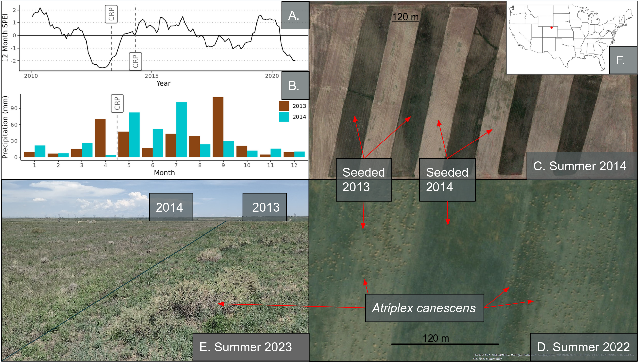

##### Figure 1

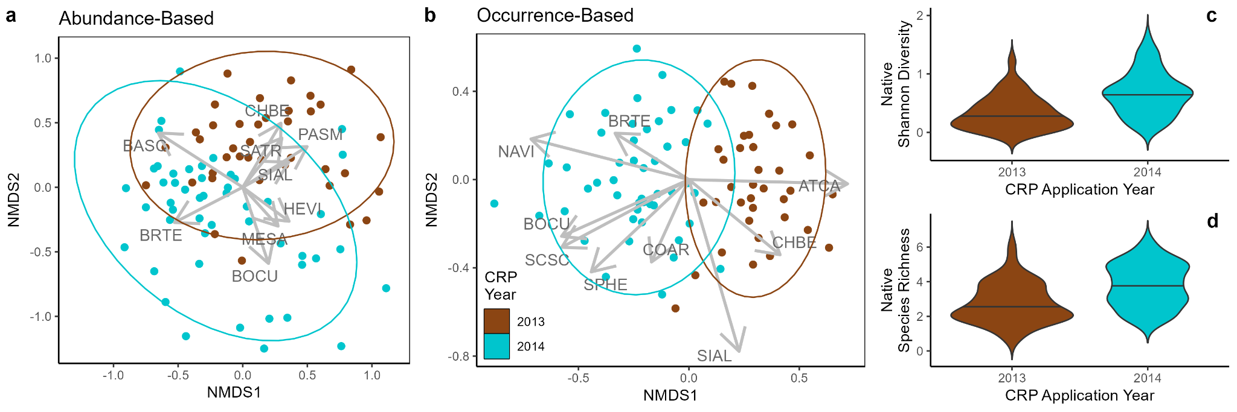

##### Figure 2

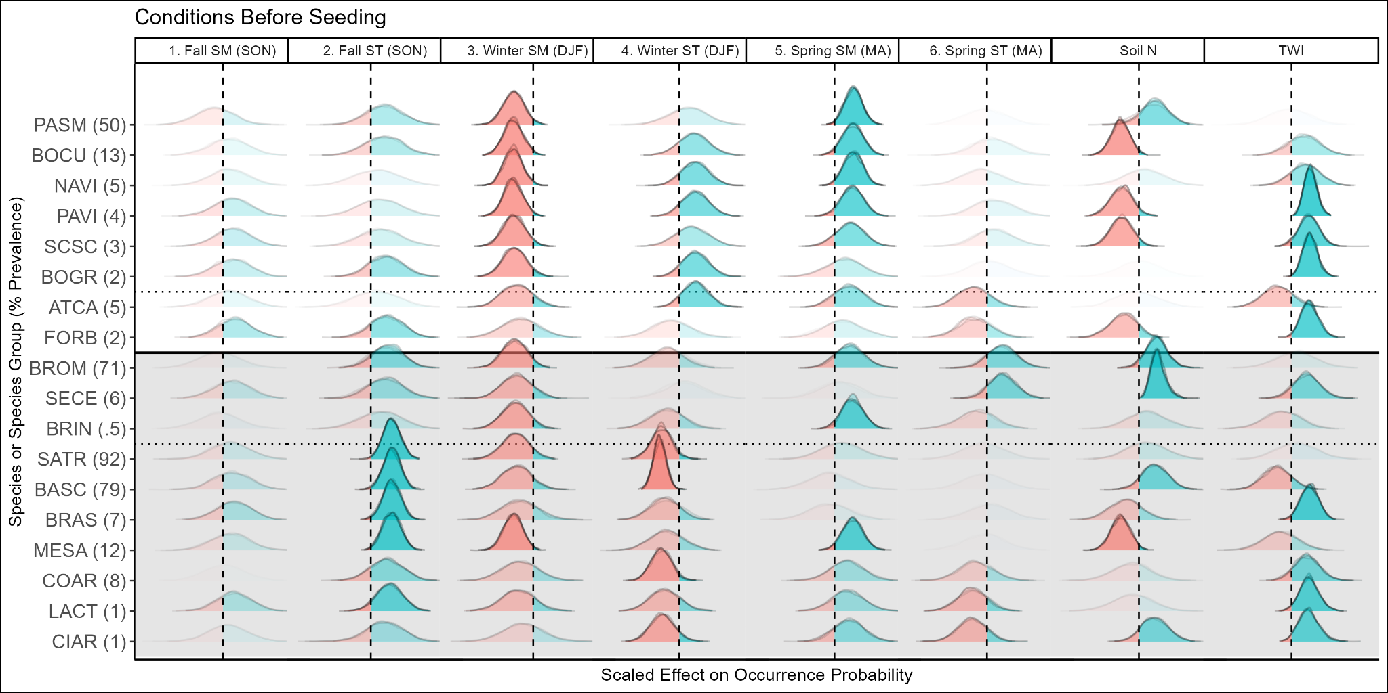

##### Figure 3

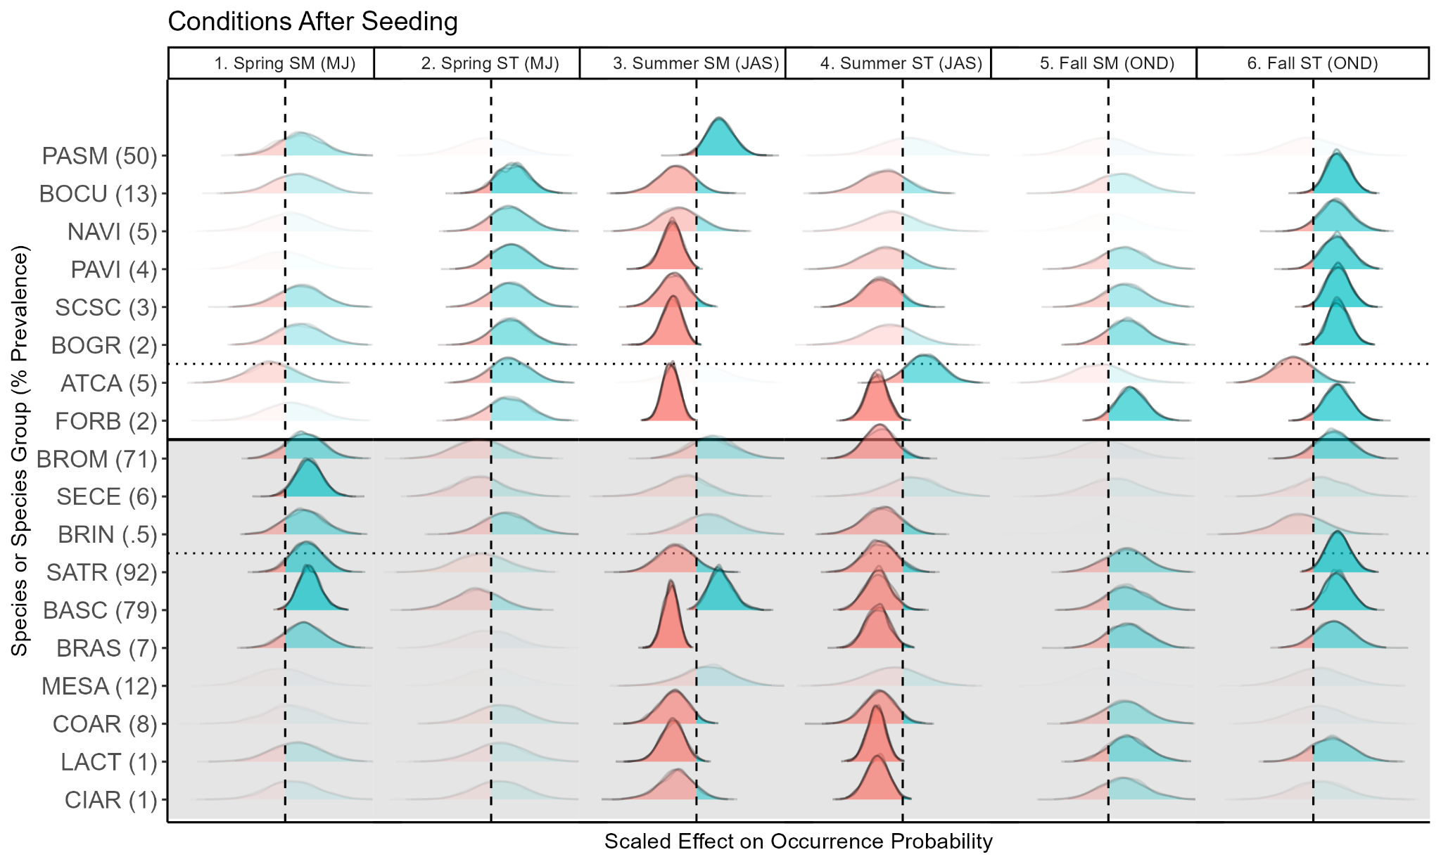

##### Figure 4

# 

##### Figure 5

##### Figure 6

# 

# 

# Appendix S1

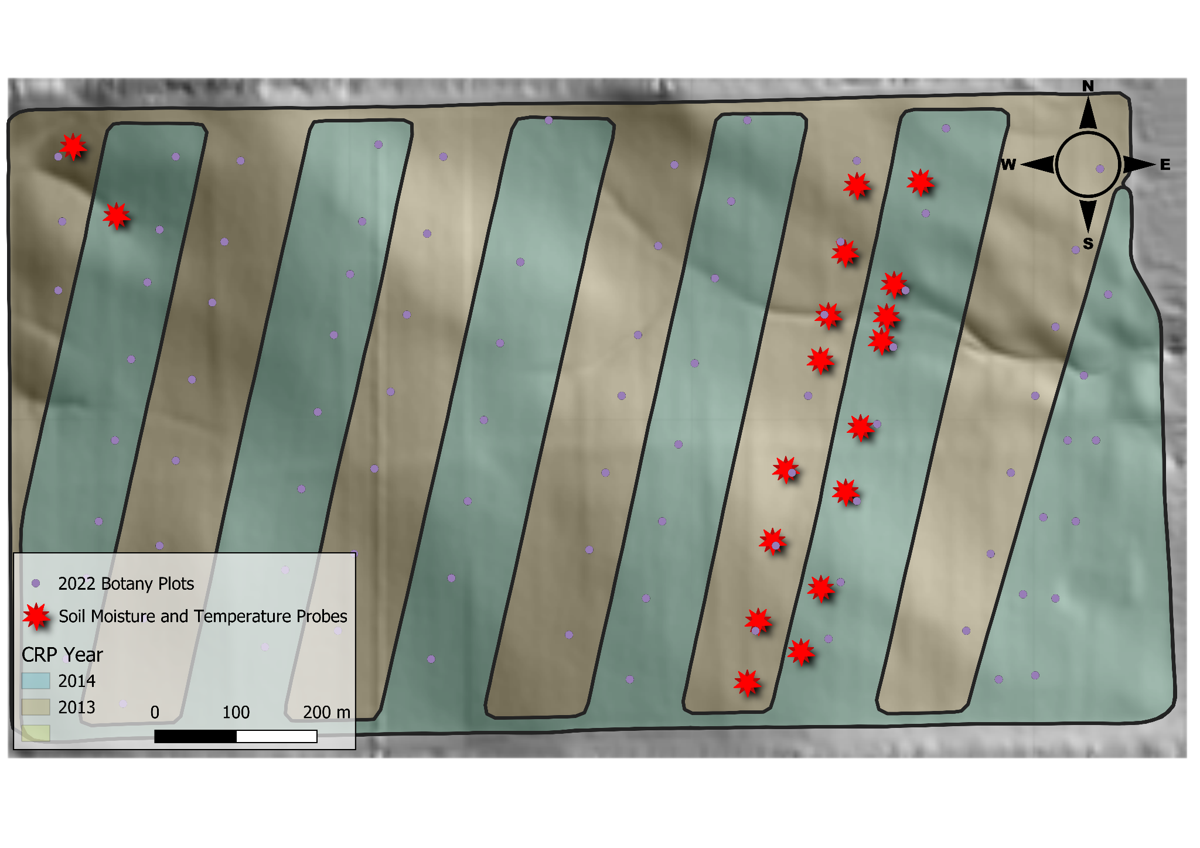

##### **Figure S1**. The study site. The background is a 5m digital elevation model, stars indicate the locations of soil temperature and moisture probes, dots indicate the location of 2022 botany plots, and the shaded areas indicate the year that the CRP seeding application was conducted. Probe locations were chosen to represent the range of topographic complexity while also allowing for the comparison of the effect of management. .

##### 

##### **Figure S2.** Species prevalence. Prevalence (number of 0.1m2 plots in which a species was encountered) for each plant species encountered across the study site for native species (a) and introduced species (b).

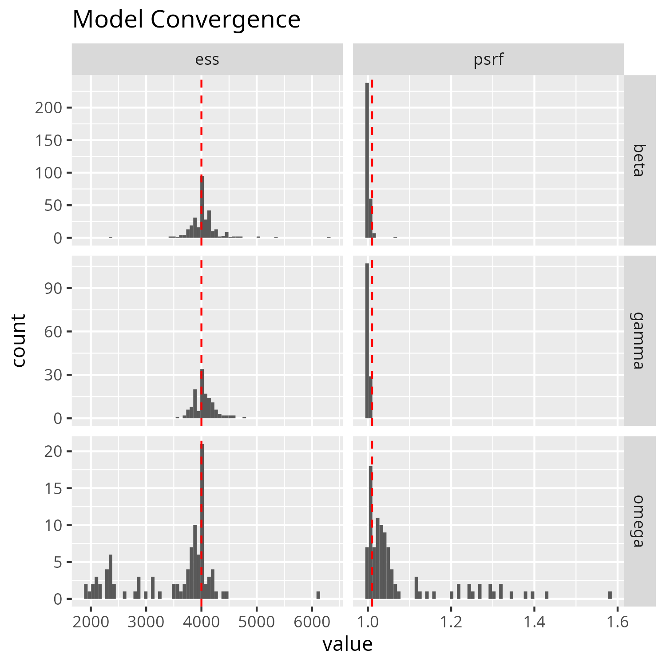

##### **FIgure S3:** Model convergence diagnostics. The potential scale reduction factor (PSRF) measures the convergence among chains, and being closer 1.0 is ideal. The vertical red dashed line lies at 1.001, a sensible target for most values to fall under. Effective sample size (ESS) measures autocorrelation between successive iterations within each chain, and higher values are better. Ideally ESS matches the number of posterior samples (indicated by the vertical red dashed line), but that is not fully necessary. Betas are the parameters for environmental filters, gammas are the parameters for the traits, and omegas are the parameters for the species associations.

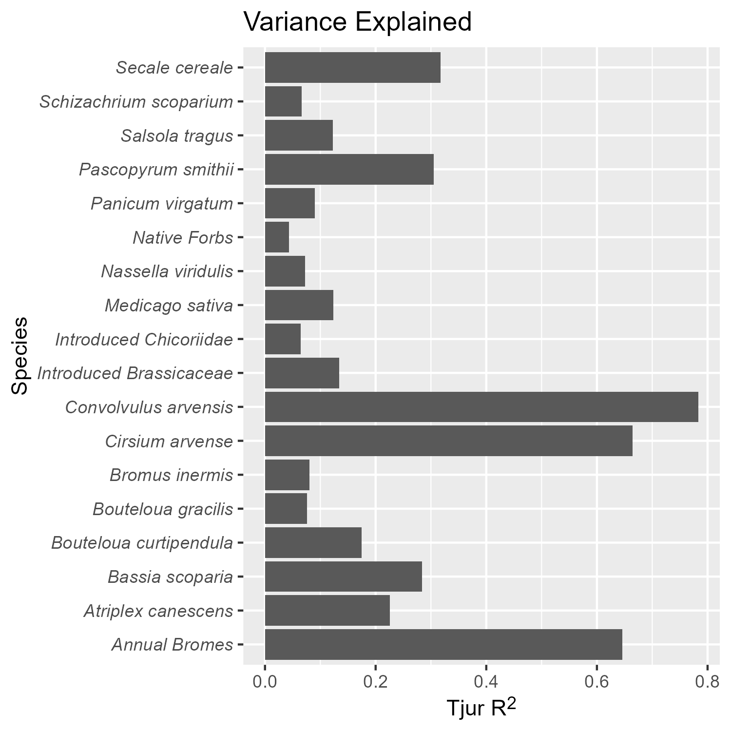

##### **Figure S4:** R2 values from the Joint Species Distribution Model for each species or species group.

##### 

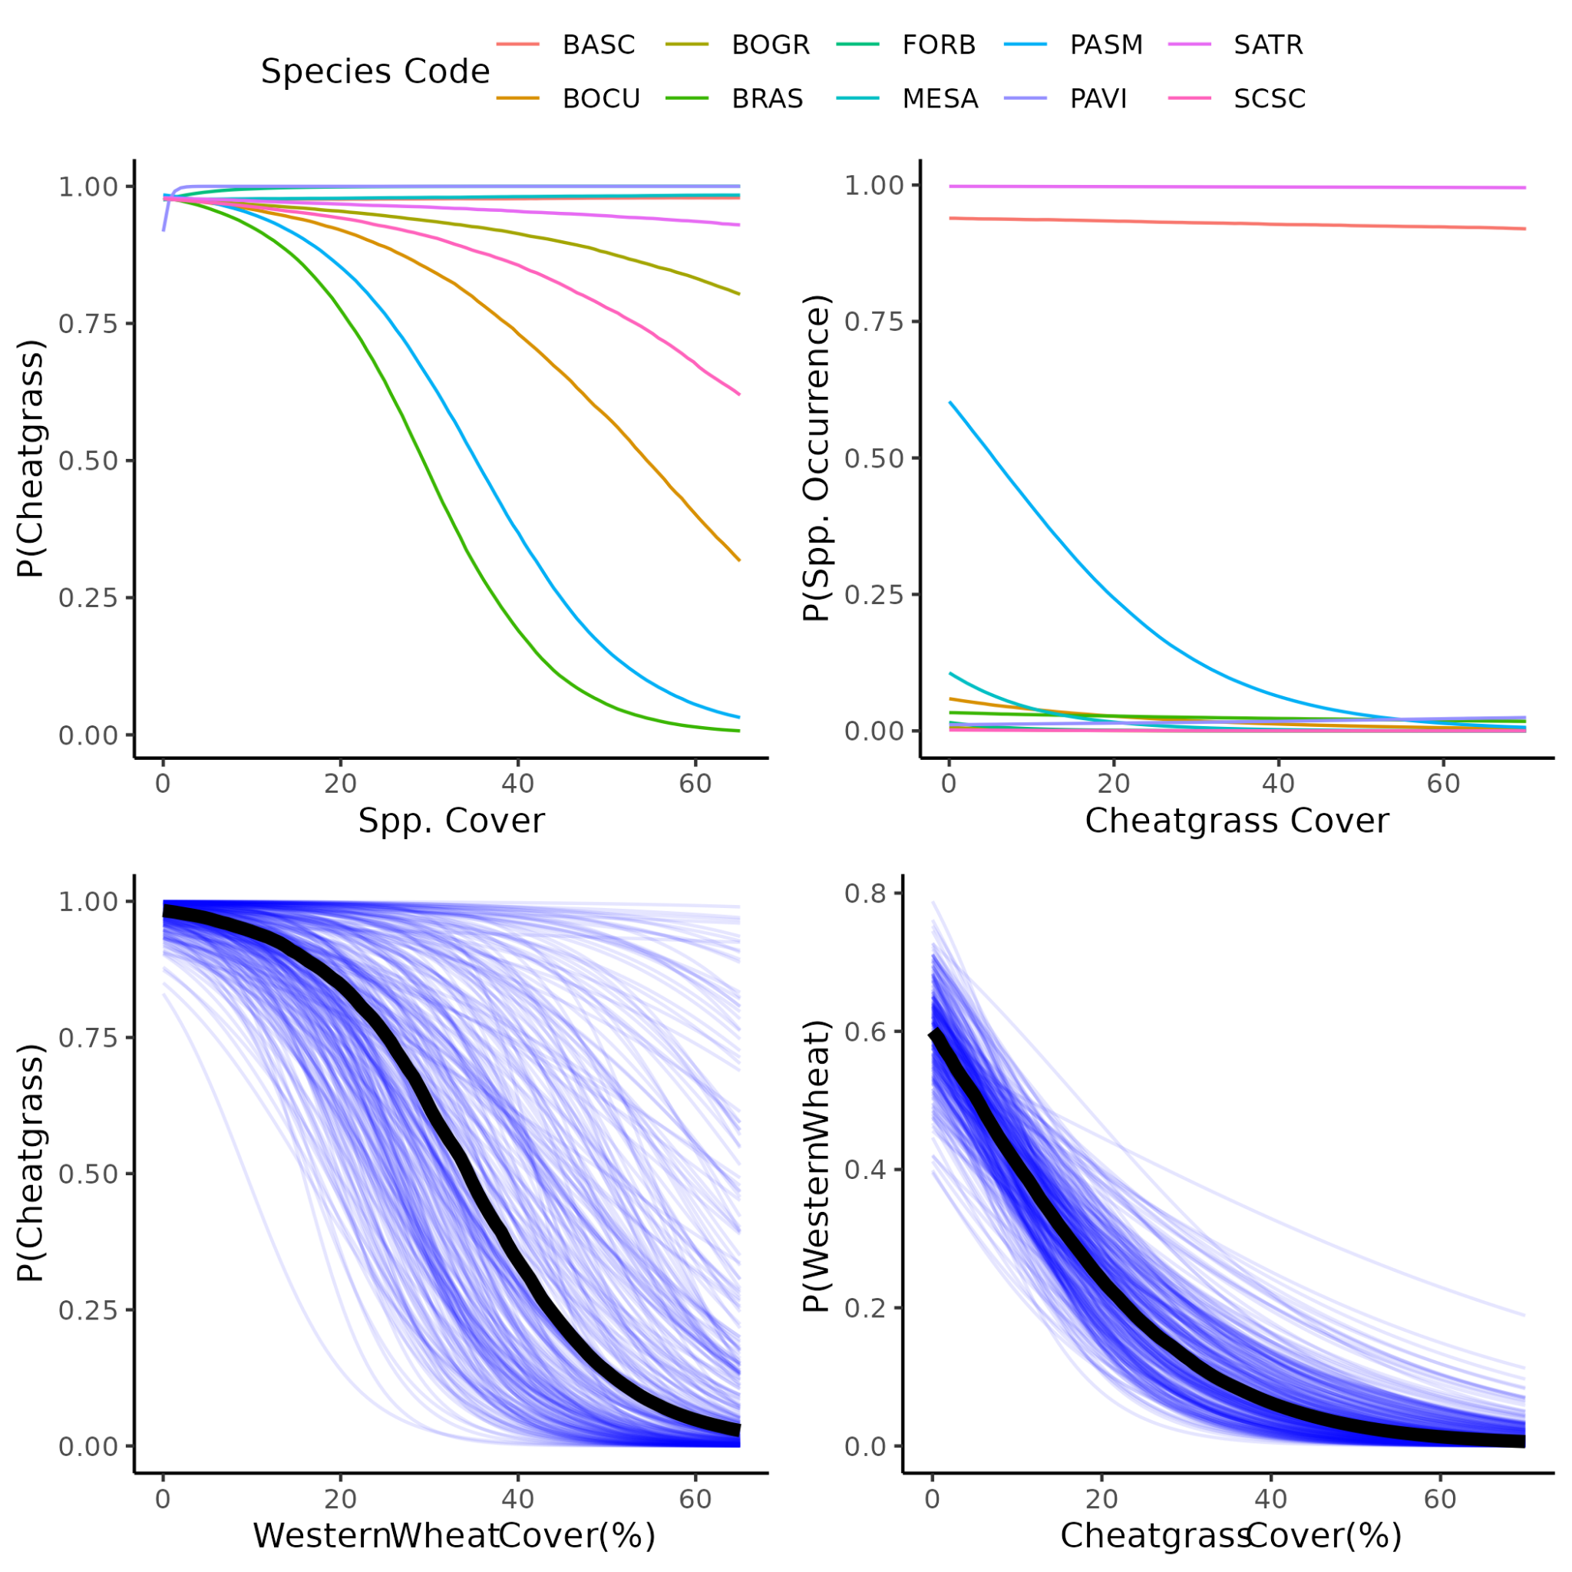

##### **Figure S5.** Western wheatgrass and cheatgrass interactions, compared to other species. This is using abundance data on the X axes to estimate the occurrence of a given species. Western wheatgrass and cheatgrass had strong effects on each others’ occurrence, compared to other species. This was consistent with field observations. Abbreviations are defined in Table S1.

##### 

##### **Table S1**: All species encountered. Many species were encountered outside of the 0.1 m2 quadrats used for the JSDM. Therefore these species were not assigned to groups, but were still used in the diversity calculations. Nomenclature follows the United States Department of Agriculture’s Plant Database (https://plants.usda.gov).

|  |  |  |  |  |  |  |  |
| --- | --- | --- | --- | --- | --- | --- | --- |
| Family | Genus | Specific epithet | Group Code | Group Name | CRP Mix | origin | Pure Live Seed  (kg/ha) |
| Asteraceae | *Gutierrezia* | *sarothrae* | GUSA | *Gutierrezia sarothrae* | no | native |  |
| Asteraceae | *Ericameria* | *nauseosa* | ERNA | *Ericameria nauseosa* | no | native |  |
| Asteraceae | *Heterotheca* | *villosa* | HEVI | *Heterotheca villosa* | no | native |  |
| Asteraceae | *Helianthus* | *annuus* | HEAN | *Helianthus annuus* | no | native |  |
| Asteraceae | *Stephanomeria* | *pauciflora* | FORB | Native Forbs | no | native |  |
| Asteraceae | cf *Aster* | d_081_herb_05 | FORB | Native Forbs | no | native |  |
| Asteraceae | *Antennaria* | sp. | ANSP | *Antennaria* sp | no | native |  |
| Asteraceae | *Artemisia* | *arbuscula* | ARAR | *Artemisia arbuscula* | no | native |  |
| Chenopodiaceae | *Atriplex* | *canescens* | ATCA | *Atriplex canescens* | yes | native | 0.2676 |
| Chenopodiaceae | *Chenopodium* | *berlandieri* | FORB | Native Forbs | no | native |  |
| Malvaceae | *Sphaerelcea* | *coccinea* | SPCO | *Sphaerelcea coccinea* | no | native |  |
| Papaveraceae | *Argemone* | cf *hispida* | ARHI | *Argemone cf hispida* | no | native |  |
| Poaceae | *Bouteloua* | *curtipendula* | BOCU | *Bouteloua curtipendula* | yes | native | 0.6244 |
| Poaceae | *Panicum* | *virgatum* | PAVI | *Panicum virgatum* | yes | native | 0.1784 |
| Poaceae | *Schizachyrium* | *scoparium* | SCSC | *Schizachyrium scoparium* | yes | native | 0.3568 |
| Poaceae | *Nassella* | *viridula* | NAVI | *Nassella viridula* | yes | native | 0.7136 |
| Poaceae | *Pascopyrum* | *smithii* | PASM | *Pascopyrum smithii* | yes | native | 1.784 |
| Poaceae | *Bouteloua* | *gracilis* | BOGR | *Bouteloua gracilis* | yes | native | 0.1784 |
| Poaceae | *Elymus* | *elymoides* | ELEL | *Elymus elymoides* | no | native |  |
| Solanaceae | *Solanum* | *triflorum* | FORB | Native Forbs | no | native |  |
| Nyctaginaceae | *Mirabilis* | sp | FORB | Native Forbs | no | native |  |
| unknown | Rhizomatous perennial forb | d_141_herb_09 | FORB | Native Forbs | no | native |  |
| Asteraceae | *Scorzonera* | *laciniata* | LACT | Introduced Cichorioideae | no | introduced |  |
| Asteraceae | *Taraxacum* | *officinale* | LACT | Introduced Cichorioideae | no | introduced |  |
| Asteraceae | *Tragopogon* | *dubious* | LACT | Introduced Cichorioideae | no | introduced |  |
| Asteraceae | *Cirsium* | *arvense* | CIAR | *Cirsium arvense* | no | introduced |  |
| Asteraceae | *Onopordium* | *acanthium* | ONAC | *Onopordium acanthium* | no | introduced |  |
| Asteraceae | *Lactuca* | *serriola* | LASE | *Lactuca serriola* | no | introduced |  |
| Brassicaceae | *Sisymbrium* | *altissimum* | BRAS | Introduced Brassicaceae | no | introduced |  |
| Brassicaceae | *Descurainia* | *sophia* | BRAS | Introduced Brassicaceae | no | introduced |  |
| Chenopodiaceae | *Salsola* | *tragus* | SATR | *Salsola tragus* | no | introduced |  |
| Chenopodiaceae | *Bassia* | *scoparia* | BASC | *Bassia scoparia* | no | introduced |  |
| Convolvulaceae | *Convolvulus* | *arvensis* | COAR | *Convolvulus arvensis* | no | introduced |  |
| Fabaceae | *Medicago* | *sativa* | MESA | *Medicago sativa* | yes | introduced | 0.3568 |
| Fabaceae | *Melilotus* | *officinale* | MEOF | *Melilotus officinale* | no | introduced |  |
| Poaceae | *Bromus* | *tectorum* | BROM | Introduced Annual *Bromus* | no | introduced |  |
| Poaceae | *Secale* | *cereale* | SECE | *Secale cereale* | no | introduced |  |
| Poaceae | *Bromus* | *inermis* | BRIN | *Bromus inermis* | no | introduced |  |
| Poaceae | *Bromus* | *secalinus* | BROM | Introduced Annual *Bromus* | no | introduced |  |
| Poaceae | *Agropyron* | *cristatum* | AGCR | *Agropyron cristatum* | no | introduced |  |
| Zygophyllaceae | *Tribulus* | *terrestris* | TRTE | *Tribulus terrestris* | no | introduced |  |

##### Table S2: R packages used in the analysis.

|  |  |  |
| --- | --- | --- |
| Package | Purpose | Citation |
| sf | Spatial vector data management | Pebesma 2018 |
| terra | Raster data management | Hijmans 2023a |
| raster | Raster data management | Hijmans 2023b |
| vegan | Diversity and NMDS | Oksanen et al 2022 |
| SPEI | Calculating SPEI | Beguería and Vicente-Serrano 2023 |
| microclima | Calculating air temperature | Mosedale et al 2023 |
| NicheMapR | Calculating air temperature | Kearney 2022 |
| topmodel | Calculating TWI | Buytaert 2022 |
| tidyverse | Data wrangling | Wickham et al 2019 |
| lubridate | Date wrangling | Grolemond and Wickham 2011 |
| vroom | Data wrangling | Hester et al 2023 |
| Hmsc | Joint species distribution modeling | Tikhonov et al 2023 |
| gghmsc | Visualization | Mahood et al 2024 |
| snow | parallelization | Tierney et al 2021 |
| fields | spatial process models | Nychka et al 2021 |
| ggpubr | visualization | Kassambara 2023 |
| ggcorrplot | visualization | Kassambara 2022 |
| ggthemes | visualization | Arnold 2021 |
| ggtext | visualization | Wilke 2021 |
| ggrepel | visualization | Slowikowski 2023 |
| ggmcmc | visualization | Fernandez i Marin 2016 |
| geomtextpath | visualization | Cameron and van den Brand 2022 |

##### **Table S3**. Species included in the CRP mix.

|  |  |  |  |
| --- | --- | --- | --- |
| Common Name | Scientific Name | Pure Live Seed Applied (kg/ha) | Origin |
| Western wheatgrass | *Pascopyrum smithii* | 1.784 | native |
| Green needlegrass | *Nassela viridula* | 0.7136 | native |
| Sideoats gramma | *Bouteloua curtipendula* | 0.6244 | native |
| Alfalfa | *Medicago sativa* | 0.3568 | introduced |
| Little bluestem | *Schizachyrium scoparium* | 0.3568 | native |
| Fourwing Saltbush | *Atriplex canescens* | 0.2676 | native |
| Blue gramma | *Bouteloua gracilis* | 0.1784 | native |
| Switchgrass | *Panicum virgatum* | 0.1784 | native |

##### Table S4 life history traits of species used in the JSDM analysis.

|  |  |  |  |  |  |  |  |
| --- | --- | --- | --- | --- | --- | --- | --- |
| species group | Mean height | introduced | perennial | woody | graminoid | rhizomatous | Photosynthetic pathway |
| Invasive Annual *Bromus* | 19 | yes | no | no | yes | no | c3 |
| *Bassia scoparia* | 11 | yes | no | no | no | no | c3 |
| *Salsola tragus* | 10 | yes | no | no | no | no | c4 |
| *Pascopyrum smithii* | 22 | no | yes | no | yes | yes | c3 |
| *Bouteloua curtipendula* | 24 | no | yes | no | yes | no | c4 |
| *Medicago sativa* | 27.5 | yes | yes | no | no | no | c3 |
| Invasive annual Brassicaceae | 21 | yes | no | no | no | no | c3 |
| *Nasella viridulis* | 41.5 | no | yes | no | yes | no | c4 |
| Invasive Chicorioideae | 10.5 | yes | yes* | no | no | no | c3 |
| Native  Forbs | 6 | no | yes | no | no | no | c4 |
| *Cirsium arvense* | 12 | yes | yes | no | no | yes | c3 |
| *Convolvulus*  *arvensis* | 8.5 | yes | yes | no | no | yes | c3 |
| *Panicum virgatum* | 27.5 | no | yes | no | yes | no | c4 |
| *Schizachyrium scoparium* | 19 | no | yes | no | yes | no | c4 |
| *Atriplex canescens* | 115 | no | yes | yes | no | no | c4 |
| *Bouteloua gracilis* | 19 | no | yes | no | yes | no | c4 |
| *Bromus inermis* | 33 | yes | yes | no | yes | yes | c3 |
| *Secale cereale* | 38.5 | yes | no | no | yes | no | c3 |

* two species (5 occurrences) are perennial/biennial, one species (1 occurrence) is annual/biennial

##### **Table S5:** Precipitation (mm) measured at the study site. Highest monthly values are bold. Highest and lowest years are italicized and bold.

| Year | **02** | **03** | **04** | **05** | **06** | **07** | **08** | **09** | **10** | **11** | **12** | **13** | **14** | **15** | **16** | **17** | **18** | **19** | **20** | **21** | **Mean** |
| --- | --- | --- | --- | --- | --- | --- | --- | --- | --- | --- | --- | --- | --- | --- | --- | --- | --- | --- | --- | --- | --- |
| **Jan** | 7 | 1 | 10 | 5 | 1 | 7 | 0 | 0 | 3 | 2 | 1 | 9 | 21 | 3 | 11 | 19 | 9 | 6 | 0 | 3 | **6** |
| **Feb** | 20 | 7 | 8 | 3 | 6 | 2 | 0 | 0 | 10 | 11 | 13 | 7 | 7 | 16 | 12 | 7 | 17 | 3 | 7 | 8 | **8** |
| **Mar** | 6 | 45 | 2 | 33 | 22 | 37 | 13 | 7 | 18 | 8 | 0 | 15 | 26 | 5 | 44 | 29 | 24 | 46 | 29 | 23 | **22** |
| **Apr** | 7 | **64** | 28 | 47 | 9 | 20 | 17 | 69 | **94** | 26 | 13 | 70 | 4 | 56 | **59** | 57 | 16 | 32 | 21 | 48 | **38** |
| **May** | **42** | 55 | 33 | 37 | 26 | 29 | 41 | 43 | 79 | **119** | 45 | 47 | 82 | ***153*** | 46 | **111** | **95** | **66** | **47** | **68** | **63** |
| **Jun** | 33 | 43 | **55** | **104** | 6 | 11 | 50 | 83 | 51 | 35 | 15 | 17 | 52 | 51 | 38 | 4 | 33 | 44 | 43 | 21 | **39** |
| **Jul** | 9 | 4 | 28 | 6 | **28** | **62** | 9 | 51 | 75 | 94 | **91** | 43 | **101** | 57 | 12 | 32 | 41 | 21 | 3 | 17 | **39** |
| **Aug** | 16 | 44 | 35 | 14 | 10 | 37 | **105** | 31 | 37 | 5 | 0 | 40 | 24 | 20 | 23 | 54 | 8 | 17 | 11 | 9 | **27** |
| **Sep** | 23 | 11 | 53 | 3 | 16 | 24 | 37 | 12 | 2 | 17 | 40 | **111** | 31 | 2 | 8 | 35 | 5 | 25 | 13 | 11 | **24** |
| **Oct** | 11 | 1 | 24 | 74 | 20 | 0 | 12 | **132** | 18 | 56 | 21 | 21 | 12 | 54 | 10 | 26 | 16 | 15 | 15 | 7 | **27** |
| **Nov** | 10 | 6 | 8 | 6 | 9 | 3 | 2 | 10 | 24 | 10 | 4 | 5 | 16 | 23 | 4 | 9 | 10 | 20 | 8 | 10 | **10** |
| **Dec** | 0 | 8 | 0 | 1 | **28** | 7 | 6 | 18 | 8 | 12 | 3 | 9 | 10 | 22 | 8 | 4 | 1 | 21 | 11 | 8 | **9** |
| **Sum** | 183 | 289 | 285 | 334 | ***181*** | 238 | 293 | 456 | 418 | 396 | 247 | 394 | 386 | ***462*** | 276 | 388 | 275 | 316 | 210 | 232 | **313** |

##### Supplementary References

Jeffrey B. Arnold (2021). ggthemes: Extra Themes, Scales and Geoms for 'ggplot2'. R package version 4.2.4.

[https://CRAN.R-project.org/package=ggthemes](https://cran.r-project.org/package=ggthemes)

Santiago Beguería and Sergio M. Vicente-Serrano (2023). SPEI: Calculation of the Standardized Precipitation-Evapotranspiration Index. R package version 1.8.1.

[https://CRAN.R-project.org/package=SPEI](https://cran.r-project.org/package=SPEI)

Wouter Buytaert (2022). topmodel: Implementation of the Hydrological Model TOPMODEL in R. R package version 0.7.5.

[https://CRAN.R-project.org/package=topmodel](https://cran.r-project.org/package=topmodel)

Allan Cameron and Teun van den Brand (2022). geomtextpath: Curved Text in 'ggplot2'. R package version 0.1.1.

[https://CRAN.R-project.org/package=geomtextpath](https://cran.r-project.org/package=geomtextpath)

Xavier Fernández i Marín (2016). ggmcmc: Analysis of MCMC Samples and Bayesian Inference. Journal of Statistical Software, 70(9), 1-20

[www.doi.org/10.18637/jss.v070.i09](http://www.doi.org/10.18637/jss.v070.i09)

Garrett Grolemund, Hadley Wickham (2011). Dates and Times Made Easy with lubridate. Journal of Statistical Software, 40(3), 1-25.

<https://www.jstatsoft.org/v40/i03/>

Jim Hester, Hadley Wickham and Jennifer Bryan (2023). vroom: Read and Write Rectangular Text Data Quickly. R package version 1.6.3.

[https://CRAN.R-project.org/package=vroom](https://cran.r-project.org/package=vroom)

Robert J. Hijmans (2023a). terra: Spatial Data Analysis. R package version 1.7-29.

[https://CRAN.R-project.org/package=terra](https://cran.r-project.org/package=terra)

Robert J. Hijmans (2023b). raster: Geographic Data Analysis and Modeling. R package version 3.6-20.

[https://CRAN.R-project.org/package=raster](https://cran.r-project.org/package=raster)

Alboukadel Kassambara (2022). ggcorrplot: Visualization of a Correlation Matrix using 'ggplot2'. R package

version 0.1.4. [https://CRAN.R-project.org/package=ggcorrplot](https://cran.r-project.org/package=ggcorrplot)

Alboukadel Kassambara (2023). ggpubr: 'ggplot2' Based Publication Ready Plots. R package version 0.6.0.

[https://CRAN.R-project.org/package=ggpubr](https://cran.r-project.org/package=ggpubr)

Michael Kearney (2022). NicheMapR: R implementation of Niche Mapper software for biophysical modelling. R package version 3.2.0.

<https://github.com/mrke/NicheMapR>

Adam L. Mahood (2024). gghmsc: Make nice plots for working with Hmsc JSDMs. R package version 0.1.2. <https://github.com/admahood/gghmsc>

Jonathan Mosedale, Jonathan Bennie and James Duffy (2023). microclima: microclimate modelling with R. R package version 0.1.0.

<https://github.com/ilyamaclean/microclima>

Douglas Nychka, Reinhard Furrer, John Paige, Stephan Sain (2021). “fields: Tools for spatial data.” R package version 14.1.

<https://github.com/dnychka/fieldsRPackage>

Jari Oksanen, Gavin L. Simpson, F. Guillaume Blanchet, Roeland Kindt, Pierre Legendre, Peter R. Minchin, R.B. O'Hara, Peter Solymos, M. Henry H. Stevens, Eduard Szoecs, Helene Wagner, Matt Barbour, Michael Bedward, Ben Bolker, Daniel Borcard, Gustavo Carvalho, Michael Chirico, Miquel De Caceres, Sebastien Durand, Heloisa Beatriz Antoniazi Evangelista, Rich FitzJohn, Michael Friendly, Brendan Furneaux, Geoffrey Hannigan, Mark O. Hill, Leo Lahti, Dan McGlinn, Marie-Helene Ouellette, Eduardo Ribeiro Cunha, Tyler Smith, Adrian Stier, Cajo J.F. Ter Braak and James Weedon (2022). vegan: Community Ecology Package. R package version 2.6-4.

[https://CRAN.R-project.org/package=vegan](https://cran.r-project.org/package=vegan)

Pebesma, E., 2018. Simple Features for R: Standardized Support for Spatial Vector Data. The R Journal 10 (1), 439-446,

<https://doi.org/10.32614/RJ-2018-009>

Kamil Slowikowski (2023). ggrepel: Automatically Position Non-Overlapping Text Labels with 'ggplot2'. R package version 0.9.3.

[https://CRAN.R-project.org/package=ggrepel](https://cran.r-project.org/package=ggrepel)

Gleb Tikhonov, Otso Ovaskainen, Jari Oksanen, Melinda de Jonge, Oystein Opedal and Tad Dallas (2023). Hmsc: Hierarchical Model of Species Communities. R package version 3.0-14.

<https://www.helsinki.fi/en/researchgroups/statistical-ecology/software/hmsc>

Wickham H, Averick M, Bryan J, Chang W, McGowan LD, François R, Grolemund G, Hayes A, Henry L, Hester J, Kuhn M, Pedersen TL, Miller E, Bache SM, Müller K, Ooms J, Robinson D, Seidel DP, Spinu V, Takahashi K, Vaughan D, Wilke, Woo K, Yutani H (2019). “Welcome to the tidyverse.” Journal of Open Source Software, 4(43), 1686.

<https://doi.org/10.21105/joss.01686>

Claus O. Wilke and Brenton M. Wiernik (2022). ggtext: Improved Text Rendering Support for 'ggplot2'. R package version 0.1.2.

[https://CRAN.R-project.org/package=ggtext](https://cran.r-project.org/package=ggtext)